VA.gov Facility Website Relaunch

## Digital Content Strategy Website Authoring Guidance Content Types ⇔ Copy Deck Templates

**WIP**

[Digital Content Strategy  
Website Authoring Guidance   
Content Types ⇔ Copy Deck Templates](#_se4cm36g7w9a) 0

**Digital Content Strategy** **4**

How will this impact digital content? 4

Where do we start? 4

Expectations 5

Authoring Guidance for VA Health Facilities 6

Introduction 6

Content Experience Principles 6

Make it simple 6

Make it relevant 7

Help me 7

Earn my trust 7

Patient Experience Principles 7

Moments that Matter 7

Additional Authoring Guidance 8

User-Centered Content 8

18F Style Content Guide: https://content-guide.18f.gov/ 8

Health Care Content 8

Health Literacy Online: https://health.gov/healthliteracyonline/ 8

**Content Types** **9**

**Content Model** **10**

**1. Event** **11**

**2. Health care facility** **12**

Name of location* (required) 12

Image 12

Region* (required) 12

Alternate Name (optional) 13

Description* (required) 13

Facility locator* (required) 13

Patient-reported service wait times for primary & specialty care (autopopulates) 13

**3. Detail page** **15**

Title* (required) 15

Description (optional) 15

Region* (required) 15

Main content 15

Related links 16

Link teasers 16

**4. Health care system** **17**

Alternate name (optional) 17

Description* (required) 17

Banner image 17

Region* (required) 17

Our locations intro text* (required) 17

Social accounts (optional) 18

**5. Benefits hub landing page** **19**

Hub name* (required) 19

Description* (required) 19

Introduction* (required) 19

**6. Story** **19**

Title* (required) 20

Owner* (required) 20

Related Office or Region* (required) 20

Introduction* (required) 20

Story Text* (required) 21

**7. Office** **22**

Name* (required) 22

Description* (required) 22

**8. Publication** **23**

**9. Benefits detail** **24**

**10. Staff profile** **25**

**11. Press release** **26**

**12. Health service (pre-populates)** **27**

[National] Service name* (required) (autopopulates) 27

[National] Patient-friendly/alternative service name (autopopulates) 27

[National] Common conditions or procedures performed in this service (autopopulates) 27

[National] Service description* (required) (autopopulates) 28

Wait Times [auto-populates] (2) 28

Regional Health Service Offering (3) 28

[heading]Care (or Services or Resources ) we provide at VA Pittsburgh [/heading] 28

Local Health Service Offering Content Type (Locations) (4) 29

**Example Listing that federates 1)The National Service name and descriptions(1), local service offering (4), service wait times (2), regional service offering (3)** **30**

National service name (1.1) 30

Common conditions/procedures performed in the service (1.3) 31

Service Description (1.4) 31

**12a. Regional health service offering** **31**

Region* (required) 32

Regional description of service (optional) 32

Services we provide 32

Regional locations* (required) 32

**12b. Local health service offering** **33**

Facility* (required) 33

Regional Health Service Offering* (required) 33

Local description of service (optional) 34

Where to find us 34

Contact us 34

Appointment Button (launches the Make an Appointment Page) 35

Service wait times (autopopulates) 35

**13. Support service** **36**

# Digital Content Strategy

In the next year, the VA.gov digital footprint will undergo considerable evolution. A modernization strategy, including a new brand position and architecture supports this evolution. This approach, driven first by Veteran (and other relevant audience) needs, provides a more strategic approach to VA content, a deeper level of insight into key business drivers, target demographics, and audience metrics.

As healthcare consumer expectations are modernizing quickly, the VA healthcare landscape is also evolving to meet the needs of Veterans where they are. Instantaneous engagement with services, resources, and peers is driving consumer health decisions and expectations, and VA is no exception.

### How will this impact digital content?

The first critical step is to first ask, “What is content?” Content is information presented as recognizable and accessible media. In our world, information takes many forms. It may be clinical information about a new procedure. It may be quality metrics associated with that procedure. It may be as simple as telling Veterans how to schedule an appointment or where to park when they come in. It may be as complex as the qualifications for an organ donation or the details of a new benefit.

The process of transforming information into media, and then determining how, when, and where it will be disseminated, is ***content strategy***. This document offers no “out of the box” content strategy solutions. We do not yet know, for example, that “Information X is best communicated via media type Y and distributed via platform Z.” But we will get there with the help of usability studies, on-going analysis of usage metrics, and, most importantly, a willingness to try new things, fail, and try again.

### Where do we start?

The current-state of digital content at VA is saddled by inefficiencies. There is widespread internal and external consensus that information is not getting to the right places at the right times. Given the incredible volume of digital touch-points, out-of-sync silos of content development and distribution, lack of a consistent strategy to employ the voices of Veterans in designs, and inconsistent access to subject matter experts, we can safely assume that there is room for improvement.

As content creators launch and scale this new strategy for VA Health facility websites, we seek to:

* Systematically integrate the voice of Veterans, families and caregivers, and other relevant site audiences across the continuum of content on VA websites;
* Articulate clear expectations of the digital content team, public affairs, stakeholders, subject matter experts, and more;
* Engage internal partners who can help to create a strategically aligned distributed content creation model including opportunities to re-use (syndicate) relevant content across the enterprise and localizing information when opportune;
* Identify current gaps in knowledge that will need to be factored in.

## Expectations

Digital content creators act as conduits between the VA health system and the community that it serves. This is a significant responsibility that requires a deep understanding of Veterans’ perspectives along with VA’s mission and priorities on both a macro and micro level. It will be incumbent upon digital content teams to do the following:

* Understand the business and how it relates to the digital footprint (both current-state and future-state);
* Build internal processes and relationships to allow for a consistent circular flow of information between subject matter experts, content creators, and Veterans, their families, and caregivers and other relevant audiences;
* Know the audience and guide content creation according to its needs;
* Strategically create rich and relevant multi-media experiences in collaboration with design, UX, and measurement teams;
* Drive home the modernized brand position by proving it consistently.

## 

## Authoring Guidance for VA Health Facilities

### Introduction

This authoring guidance should be used by digital content creators authoring or migrating digital content for [VA Facility]. Whether you are a VA public affairs staff member, writer, IT employee, researcher, clinician, or front-line staff member (or anyone else we’ve missed here!), this guidance can help make migrating or developing content for your facility website easier for you.

Because VA health care facilities represent the primary touchpoint for Veterans who use VA health care, the first phase of this new Veteran-first experience will include a relaunch of VA health care facility websites on the new VA Content Management System (CMS), an extensible and flexible solution called **Drupal**.

As you migrate {VA Facility] content from Teamsite to Drupal, this guidance is meant to help you understand how the new authoring system can help you build digital content that better meets the needs of Veterans, their families and caregivers. To facilitate this, this guidance provides principles, guidelines, and approaches to content that help you understand how you should create, maintain, and govern digital content.

## Content Experience Principles

When creating digital content, remember that Veterans, their families, and caregivers are primary audiences. Each group should be able to easily understand the content you create. Consider the following experience principles when creating or refactoring content for facilities on VA.gov.

### Make it simple

* Be easy to find
* Make it easy to find my way once I get there
* Speak to me in plain language
* Make it easy for me to find the services and benefits I need
* Make my service and facility search easy
* Give me an appealing and visually consistent experience

### Make it relevant

* Engage me with valuable, focused, and personally relevant content
* Give me a culturally relevant and localized experience
* Allow me to choose how to connect
* Reach out to me with relevant information

### Help me

* Be there when I need it
* Make accessing services and programs easy

### Earn my trust

* Show me the VA care experience - my providers and how they will care for me
* Be transparent with me about important issues

## Patient Experience Principles

The Veterans Experience Office’s Patient Experience Program has developed a customer experience framework consisting of “Moments that Matter” that represent the key metrics of ease, effectiveness, and emotion across a Veteran’s journey at a health care facility. While facilities websites may represent a tiny part of a Veterans experience with a VA facility, considering these key moments across relevant content can help guide you to create on-brand, Veteran-first information that will help Veterans, their families, and caregivers access the information they need when they need it.

### Moments that Matter

* It was easy for me to find help in locating my appointment (effectiveness)
* I got the appointment when I needed it (ease)
* I felt heard and cared for (emotion)
* I understand what I need to do next to manage my whole health (emotion)
* It was easy to get my prescriptions filled (ease)

When developing content for facilities it might be helpful to ensure that it stands up across the moments that matter when applicable. You may want to ask yourself as you’re developing content for your facility:

* *Does the content help enable a Veteran, family member, or caregiver to locate an appointment for a service?*
* *Does the content help a Veteran, family member, or caregiver get an appointment for a service?*
* *Does the content leave a Veteran, family member, or caregiver feeling like they are heard and cared for?*
* *Does the content help a Veteran, family member, or caregiver navigate through the health system?*
* *Does the content help a Veteran, family member, or caregiver access the pharmacy and their prescription easily?*

## Additional Authoring Guidance

VA-specific guidance to help you create on-brand VA facility web content:

* VA Design System Content Principles: <https://design.va.gov/content-style-guide/content-principles>
* VA Editorial Playbook: <https://www.va.gov/playbook/editorial/>

### User-Centered Content

### 18F Content Style Guide: <https://content-guide.18f.gov/>

* Plain Language: <https://plainlanguage.gov>

### Health Care Content

### Health Literacy Online: <https://health.gov/healthliteracyonline/>

# 

# Content Types

The new website for for VA Pittsburgh (<https://staging.va.gov/pittsburgh-health-care/>) consists of different content types, all entered into the Drupal content management system (CMS). **Content types** represent various configurations of content that are distinct enough to be unique types in the system. By creating content types and relating them to one another, parts of the website are dynamically generated and require little maintenance.

Below is a list of content types that have been developed so far. Each content type is made up of content attributes. Attributes include required or optional content that make up each type and include how they relate to each other. For their definitions, attributes, and relationships, see the Content Model.

While content types and their associated templates in the CMS can help you publish pages, refer to the [VA.gov content style guide](https://design.va.gov/content-style-guide/) for additional guidance to help you create on-brand VA facility web content within these types.

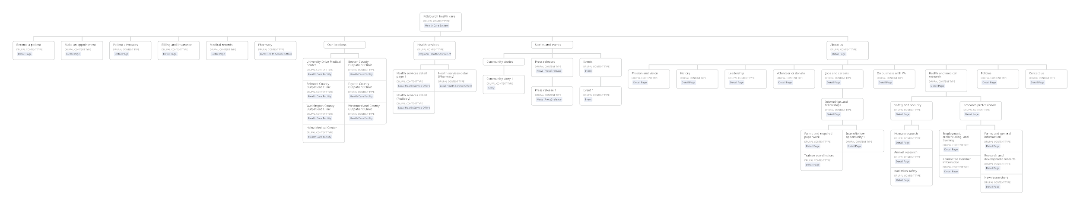  
Pittsburgh facility sitemap.

# Content Model

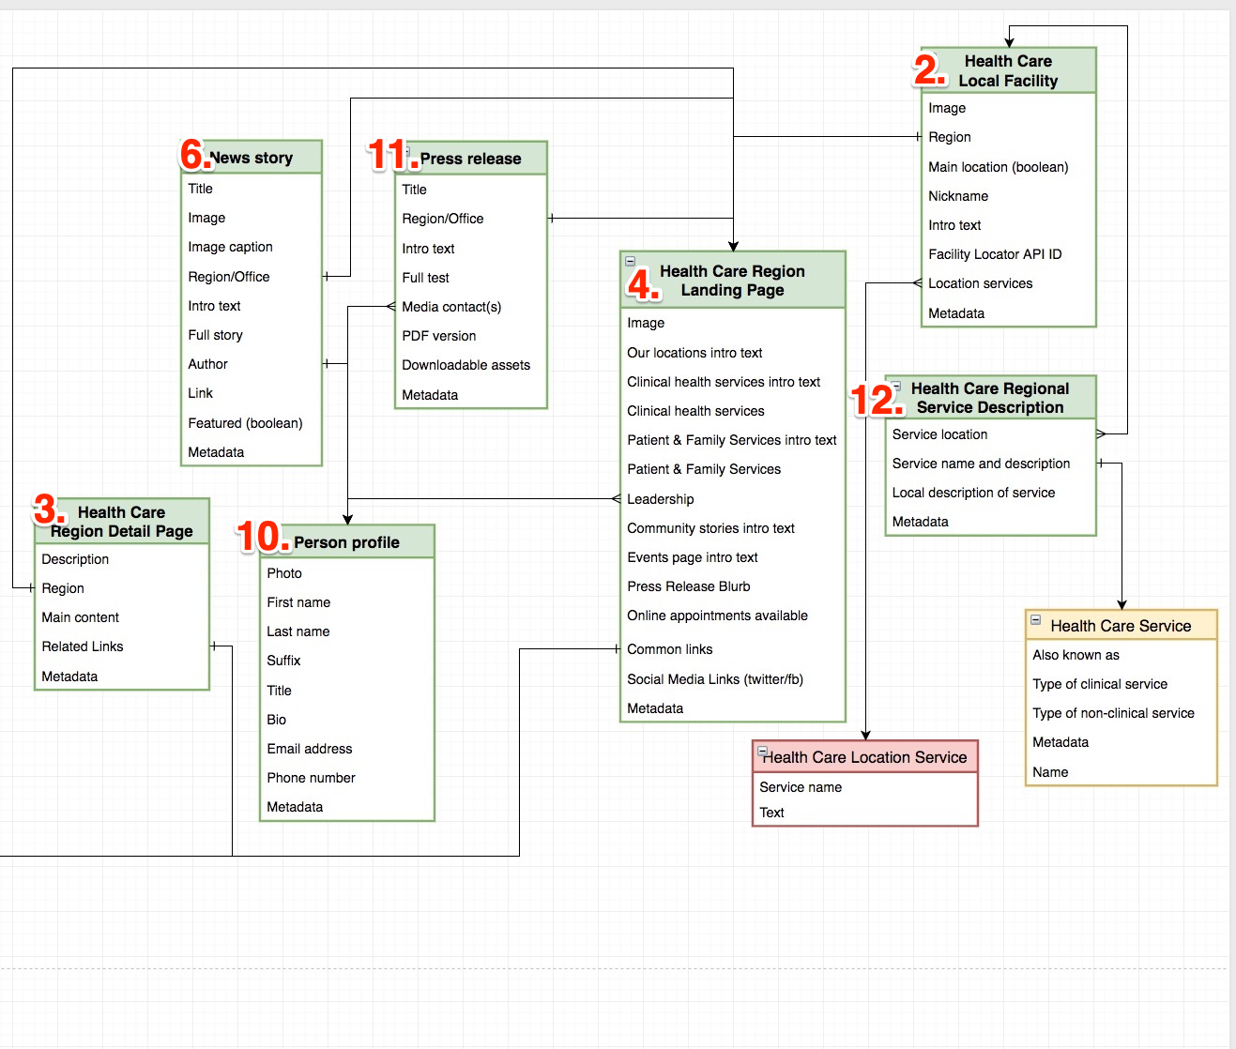

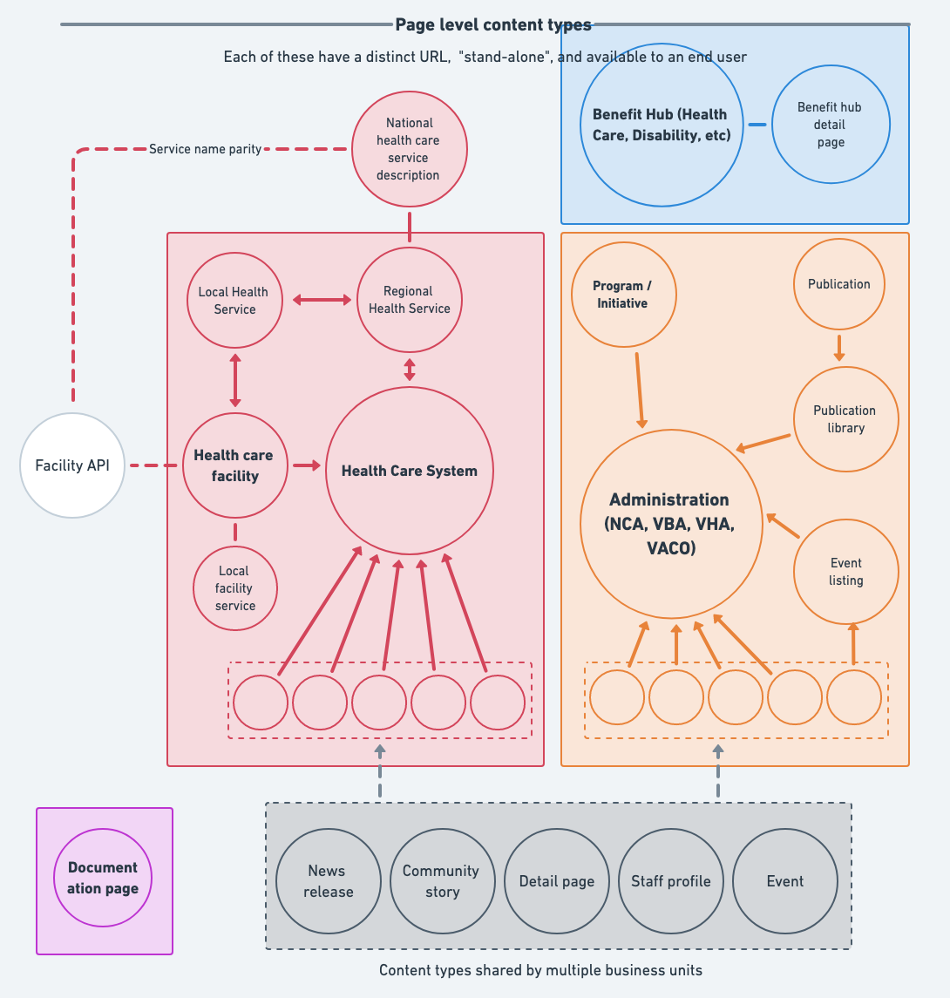

Content Type Templates (Copy Decks)

# 1. Event

The Event content type will help you easily create and publish pages for events like support groups, outreach/external events, and lectures. Events contain attributes like dates, times, descriptions, and locations.   
  
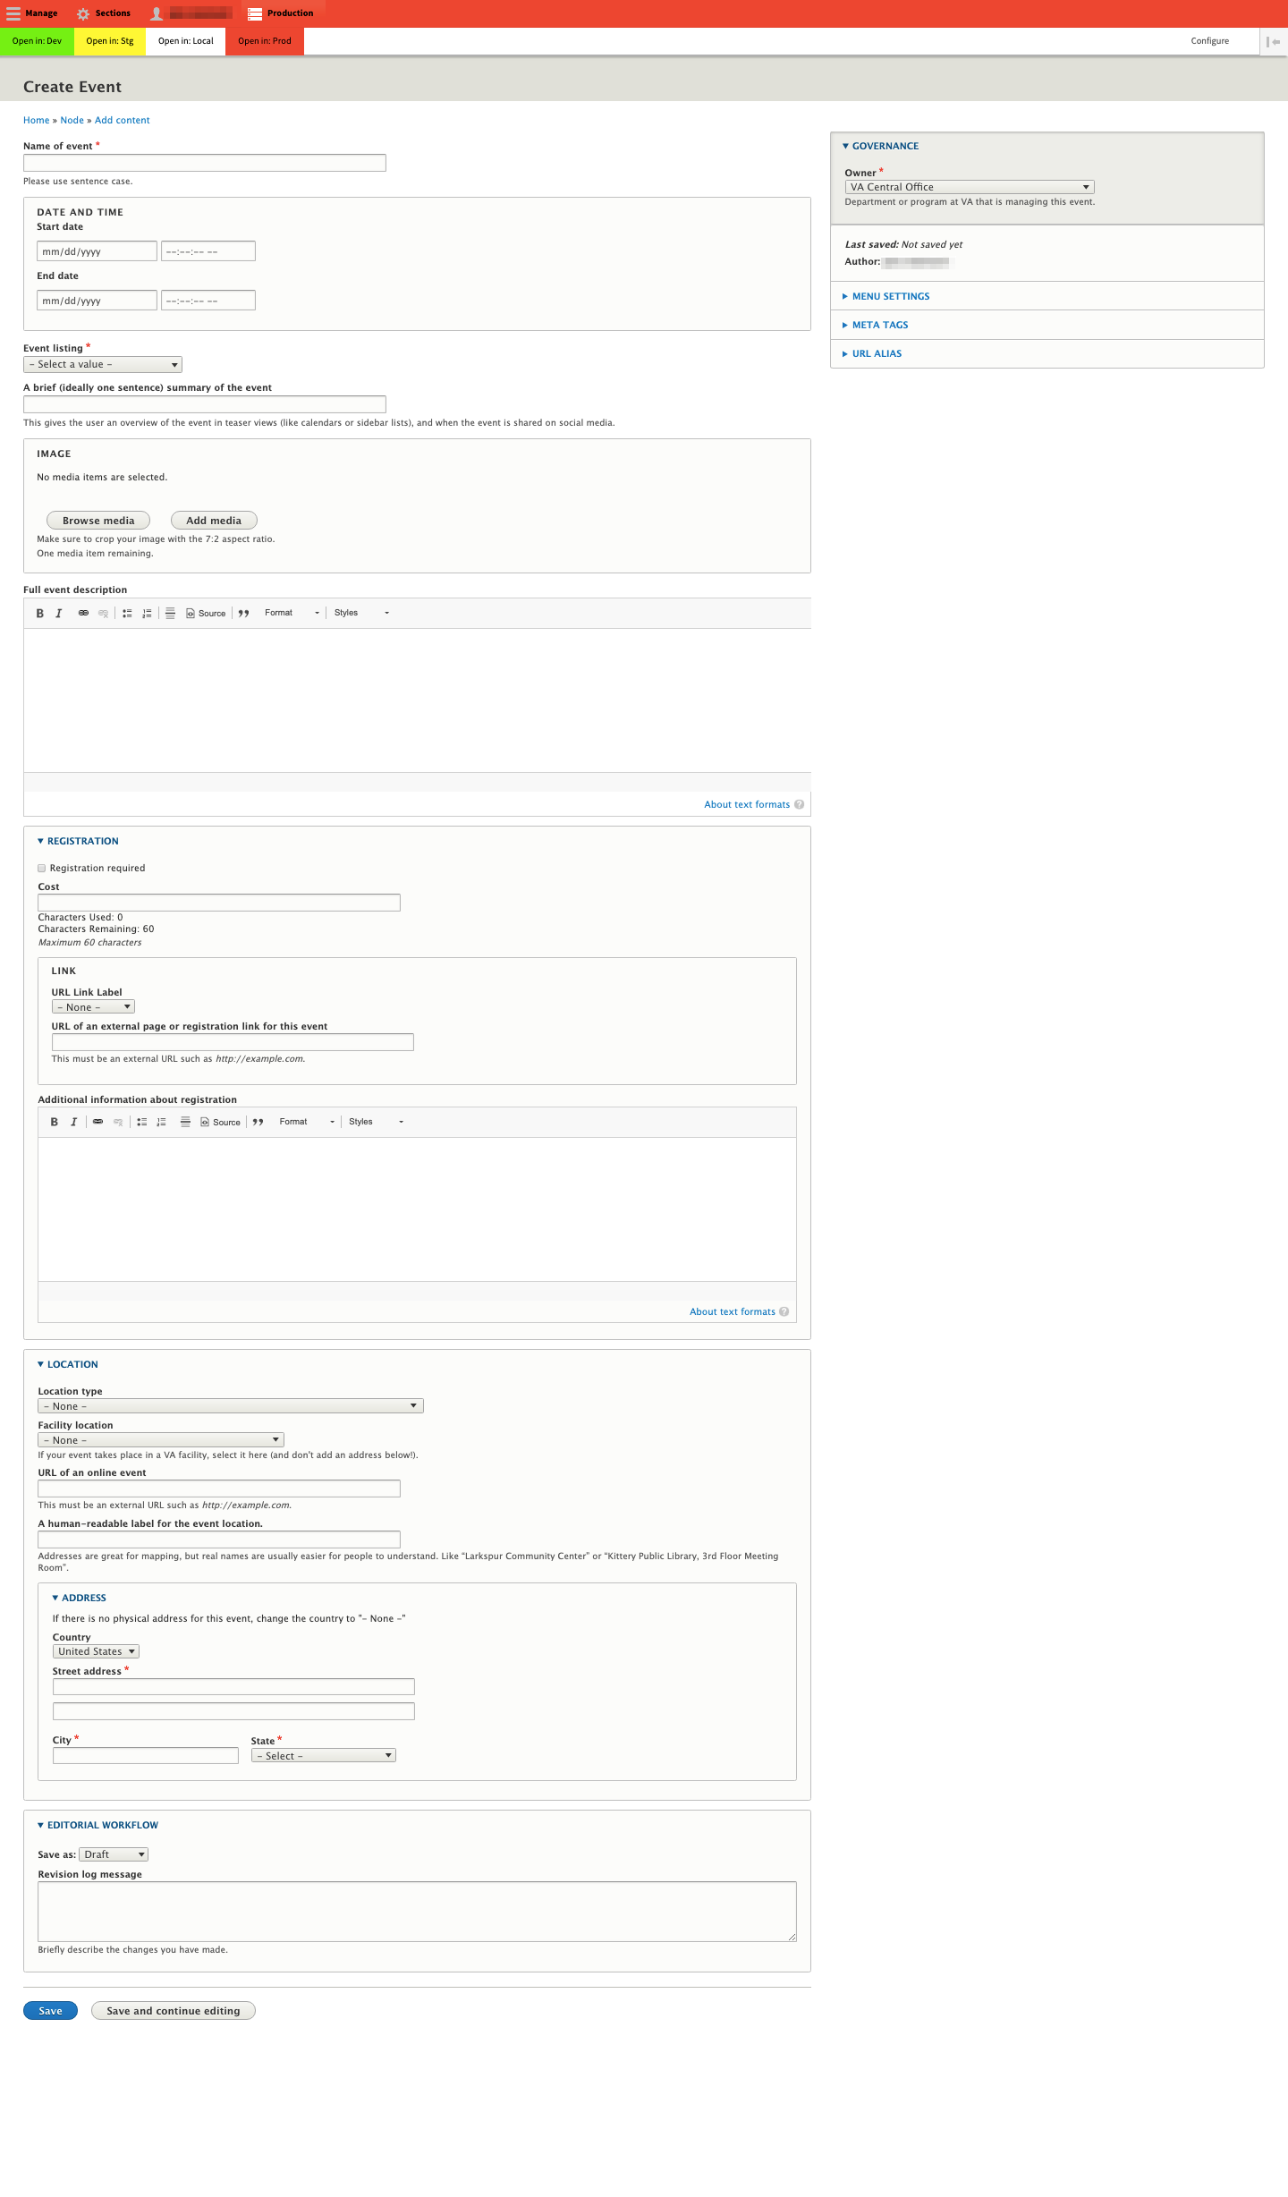

# 2. Health care facility

The Health care facility content type will help you create pages for local facilities like medical centers or outpatient clinics within a healthcare system. This content type automatically displays data from the [VA facility API](https://developer.va.gov/explore/facilities/docs/facilities) including operating hours, addresses, maps, and phone numbers. If available, wait times for select clinical services, and cumulative responses from Veterans from select SHEP survey questions about access to primary care and specialty services will appear across listings for applicable services.

## Name of location* (required)

|  |
| --- |
| *[e.g., Pittsburgh VA Medical Center - University Drive - (the page URL will be va.gov/pittsburgh-va-health-care/pittsburgh-va-medical-center-university-drive)]* |

## Image

* media

## Region* (required)

[Select value from dropdown menu]

## Alternate Name (optional)

|  |
| --- |
| *[Is this facility known by another name? If yes, add it here.]* |

## Description* (required)

|  |
| --- |
| *[Describe the facility and the services it offers. Since operating hours will be supplied by the facility API do not include this information here.]*  *Example:* [*https://staging.va.gov/pittsburgh-health-care/locations/hj-heinz-campus/*](https://staging.va.gov/pittsburgh-health-care/locations/hj-heinz-campus/) |

## Facility locator* (required)

|  |
| --- |
| *Enter your facility or station ID. (ie, vha_688) Go to* [*https://www.va.gov/find-locations/*](https://www.va.gov/find-locations/?zoomLevel=9&page=1&address=288%20Sidney%20Street%2C%20Cambridge%2C%20Massachusetts%2002139%2C%20United%20States&location=undefined%2Cundefined&context=Cambridge%2C%20Massachusetts%2002139%2C%20United%20States&facilityType=health) *and select your facility. Entering this ID will pull data from the VA facility API to automatically generate a map, facility hours, services and wait times, and data from surveys re: appointment access to primary and specialty care.* |

## Patient-reported service wait times for primary & specialty care (autopopulates)

|  |
| --- |
| *<Populated by API>* |

# 

# 

# 3. Detail page

The Detail page content type will help you create a generic page for a region website and offers a variety of design components to help you improve the page design and user experience. The detail page offers you the flexibility to publish pages where there's not another content type that meets your needs.

## Title* (required)

|  |
| --- |
| *[This title will appear as a search listing. Use sentence case, 150 characters maximum ]* |

## Description (optional)

|  |
| --- |
| *[This content often appears in search engine results and should be a brief description of the page’s content. 160 characters maximum]* |

## Region* (required)

[Select value from dropdown menu]

## Main content

|  |
| --- |
| *Main content can be displayed using any of these components in any order.*  WYSIWYG  Number Callout  [Accordion](https://department-of-veterans-affairs.github.io/vets-design-system-documentation/components/accordions)  Q&A  [Process](https://department-of-veterans-affairs.github.io/vets-design-system-documentation/components/process-list)  React Widget |

## Related links

|  |
| --- |
| *Add URL* |

## Link teasers

|  |
| --- |
| *Main content can be displayed using any of these components.* |

# 

# 4. Health care system

The Health care system content type will help you create a homepage for a VA health care system.

Name of regional health care system* (required)

|  |
| --- |
| *[e.g., Pittsburgh VA Health Care (this name will appear in page navigation as va.gov/pittsburgh-va-health-care)* |

## Alternate name (optional)

|  |
| --- |
| *[Does this region have an alternate name? If yes, add it here]* |

## Description* (required)

|  |
| --- |
| *[One sentence summary of that describes the content of the page, 160 characters maximum]* |

## Banner image

* media

## Region* (required)

[Select value from dropdown menu]

## Our locations intro text* (required)

|  |
| --- |
| *[Describe the locations]* |

## Social accounts (optional)

|  |
| --- |
| *Facebook URL* |

## 

|  |
| --- |
| *Twitter URL* |

## 

|  |
| --- |
| *Instagram URL* |

## 

|  |
| --- |
| *Flickr URL* |

## 

|  |
| --- |
| *Email List* |

# 

# 5. Benefits hub landing page

The Benefits hub landing page content type will help you create home pages for VA benefits areas, including disability compensation, education, employment, health care, home loans, life insurance, memorial benefits, and pension. These pages display top-level benefits content with its own layout and content.

## Hub name* (required)

|  |
| --- |
| *[e.g., Health Care (this name will appear in page navigation as va.gov/health-care)* |

## Description* (required)

|  |
| --- |
| *[One sentence summary of that describes the content of the page, 160 characters maximum]* |

## Introduction* (required)

|  |
| --- |
|  |

## 

# 

# 6. Story

The Story Content Type is a great marketing tool to introduce readers to interesting, newsworthy items at your region or facility. Community stories highlight the role of a VA facility, program, or healthcare system in a Veteran's journey. They may be a case study of a specific patient, a description of a new or successful program, or a community-interest story

Treat stories as content that will draw readers in to learn more about an area on the website. Potential topics include interviews, news features, descriptions of awards or other honors or anything else that might capture a reader’s interest.

This content type can be cross-published and associated with any relevant facility. If the article you’re entering should appear across multiple locations, select these entities from the dropdown menus. The content will appear across each section of each entity that you select.

## Title* (required)

|  |
| --- |
| *[The title of this story, in sentence case]* |

## Owner* (required)

[Select value from pick list]

## Related Office or Region* (required)

[Select value from pick list]

## Introduction* (required)

|  |
| --- |
| *[One sentence summary of the story this page describes. Displayed in the teaser viewof each story. Often appears in search results. 160 characters maximum]* |

## Story Text* (required)

|  |
| --- |
|  |

# 

# 7. Office

The Office content type will help you publish listings and descriptions of individual VA offices that can be re-used across the website and mapped to other content types when an Office record is associated with that content. The Office content type may contain contact info, events, news, and a leadership page in some cases.

## Name* (required)

|  |
| --- |
| *[Name of office]* |

## Description* (required)

|  |
| --- |
| *[Description of this office]* |

## 

# 

# 8. Publication

The Publication Content Type hosts files, images, videos, newsletters, and posters that can be shared across the system. These assets can be also shared with VSOs and Veterans to assist in outreach and related communications efforts.

# 

# 9. Benefits detail

The Benefits detail content type will help you create benefits overview content, similar to the content currently displayed on va.gov/disability, va.gov/health-care, and va.gov/education.

# 

# 10. Staff profile

The Staff profile content type will help you create profiles of staff for display in various places around the site.

# 

# 11. Press release

The Press release content type will help you create announcements directed to members of the media to publicize newsworthy events/happenings/programs at specific facilities or healthcare systems.

# 

# 12. Health service (pre-populates)

To create consistency in service descriptions across VHA, the DSVA team, working with the Office of Digital Communications at VHA, has developed a draft list of approximately 100 services offered across VHA drawn from a review and consolidation of over 2000 service names across VA facility websites.

In addition to this list, each service includes an easily understandable, Veteran-centric short description that includes related patient-friendly or alternative names and related conditions or procedures when applicable. These descriptions can be cross-published across at any VA facility that offers the service. If your facility has a service that is listed in the national list of services and you would like for it to be included or have feedback regarding an existing service name or description, please [contact us](mailto:jane.newman3@va.gov).

## [National] Service name* (required) (autopopulates)

[Select value from dropdown menu]

## [National] Patient-friendly/alternative service name (autopopulates)

|  |
| --- |
| *In some cases, a Service may have a patient-friendly or alternate name). The field may autopopulate with alternate names.* |

## [National] Common conditions or procedures performed in this service (autopopulates)

|  |
| --- |
| *Sometimes autopopulates with common conditions or procedures performed within the service. May mitigate the need to list conditions manually in regional/local fields. (eventually this can be linked to relevant health content globally)* |

## [National] Service description* (required) (autopopulates)

|  |
| --- |
| *[The description has been written by and autopopulates the field]* |

### Wait Times [auto-populates] (2)

If wait times for your service are included in the VA Facility API, they will be displayed within the Service accordion under your facility.

## Regional Health Service Offering (3)

You have the option to include custom regional content that describes your region’s Service offering in addition to the description of the national Service offering. Because this content block describes the Service offering across your system, provide general information about the service that might apply to all the locations where the service is offered. Do not provide information for an internal audience. We recommend using short phrases and including no more than six bullets so readers can scan the page and easily find key information.

See the screenshot example section 3 above for example content. We recommend the following format if applicable to your service:

### [heading]**Care (or Services or Resources ) we provide at VA Pittsburgh** [/heading]

*Describe the Service that expands upon the National service description and provides additional details about your Service that are relevant to Veterans and specific to your region or facility. We recommend a 1-2 sentence introduction followed by a bulleted list of 5-6 items. Bullets can be complete sentences, if needed.*

*Regional service description [1-2 sentences, if needed]*

*Bullet points: 5-6 max per service. These can be complete sentences, if needed.*

*Button or link Optional, to link to detail pages.*

### Local Health Service Offering Content Type (Locations) (4)

 The Local health service offering displays contact information, service hours, and location information for the Service, along with any specific information related to the service at the location. See the screenshot [section 4] above for example local service offering content.

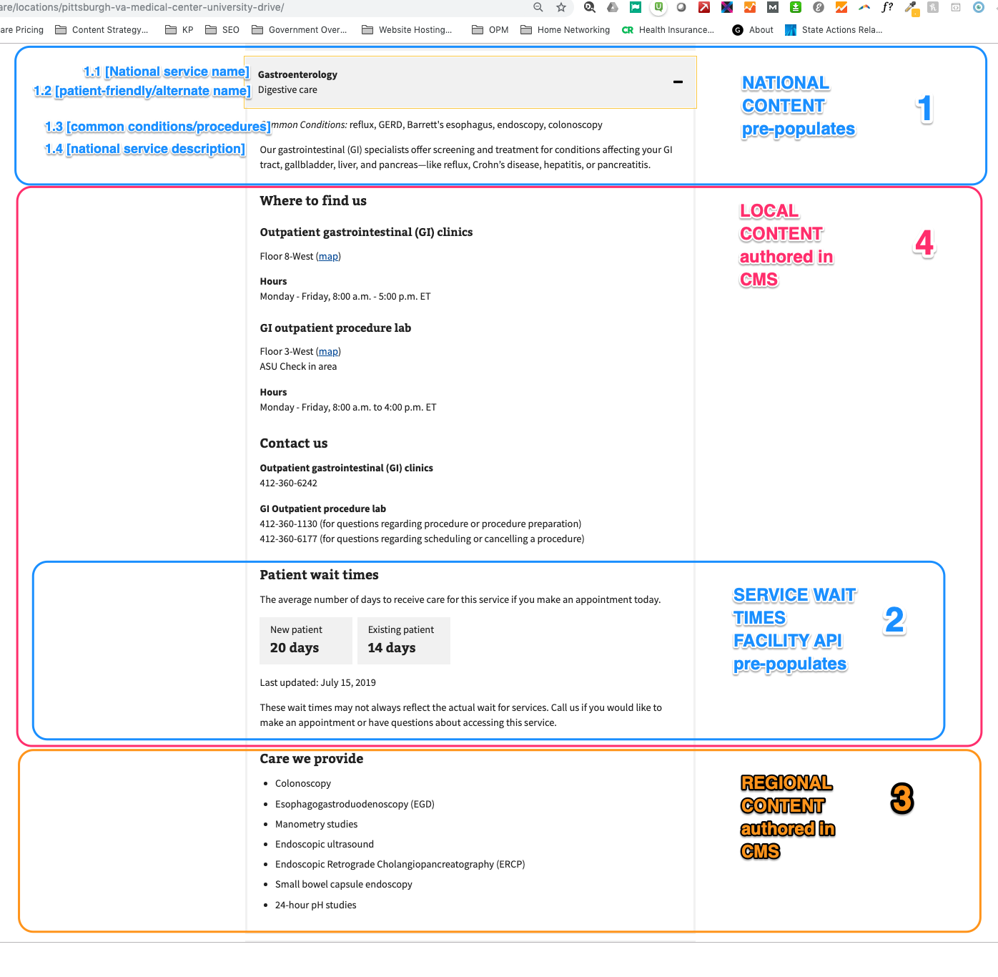

# Example Listing that federates 1)The National Service name and descriptions(1), local service offering (4), service wait times (2), regional service offering (3)

### National service name (1.1)

The Service offering name comes from a taxonomy of Services offered across VA facilities. Patient-friendly name/alternate name (1.2)

Because there is variation in naming across the system, we provide patient-friendly or alternate names when applicable.

### Common conditions/procedures performed in the service (1.3)

If applicable, the section provides the common conditions or procedures performed within a service to help readers understand what the service does and what conditions they treat.

### **Service Description (1.4)**

Fewer than 200 characters, the Service description provides a general summary of the Service. Written with the Veteran in mind, these descriptions can be used as standalone content on your page, provided that you add applicable local contact information for the Service at your facility.

# 12a. Regional health service offering

The Regional health service offering content type will help you create content for a service available at regional and local facilities. Each VA health care service (ie, primary care, mental health, geriatrics, audiology, psychiatry, etc.) includes a short general description is shared across all facilities, and pre-populates the page template. These national service descriptions are approved by VHA and will pre-populate the first few lines in the service offering’s description. These can be cross published across any VA facility that offers the service. Subsequent content is authored locally, describes the service in your region [VA Pittsburgh] and is authored locally. When regional healthcare systems need to add additional content that more fully describes the service at their region, they do it here.

The regional health service content type should encourage high-priority calls to action for the user like making an appointment or accessing a service. It should:

* Include relevant information about the service or program for patients, caregivers, and families.
* Subsequently describe what makes the service unique at this region/location or expands on the national description.

## Region* (required)

[Select value from dropdown menu]

## Regional description of service (optional)

|  |
| --- |
| *[If necessary, expand of the National description or describe any unique characteristics of the service across your regional system. It is not necessary to duplicate content that is displayed in the National service description.]* **Services we provide** Our comprehensive laboratories provide a full range of clinical and diagnostic testing services including:   * Routine blood testing * Urinalysis * Metabolic testing * TB, hepatitis, HIV testing * Genetic testing |

## Regional locations* (required)

|  |
| --- |
|  |

# 12b. Local health service offering

The Local health service offering content type will help you create a page for a facility-specific description of a health care service. It addends the regional description.

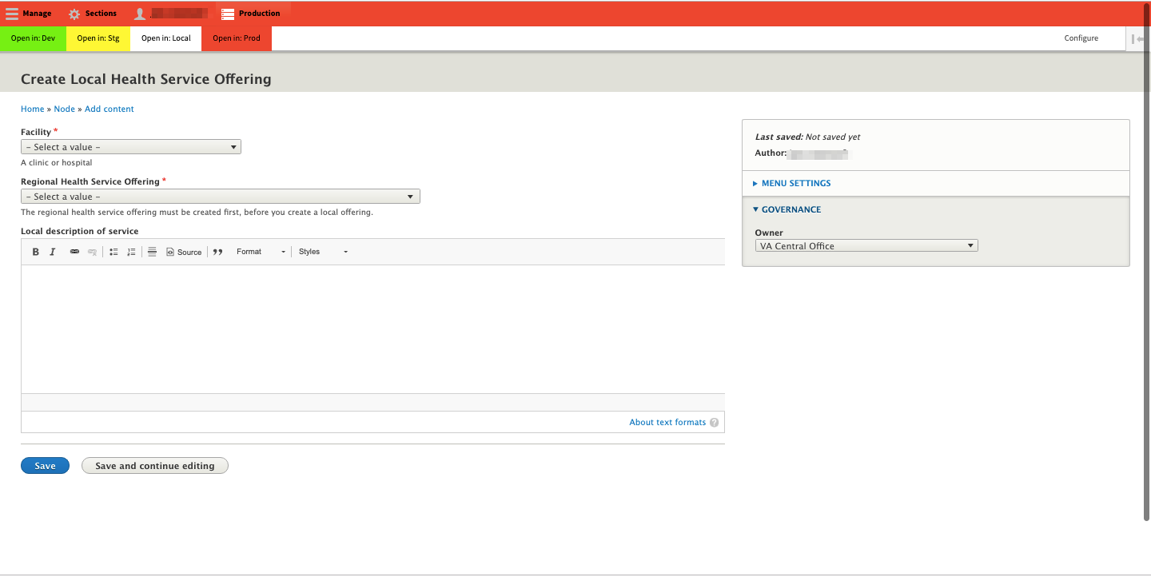

## Facility* (required)

* Select facility

## Regional Health Service Offering* (required)

* Select relevant regional service offering

## Local description of service (optional)

|  |
| --- |
| *[provide relevant information about the service that is specific to the location, see below for an example of local content for Laboratory and pathology.]*  We offer blood and other advanced testing services to help you and your VA health care team monitor your health, find and understand any health problems, and make informed treatment decisions. **Where to find us**  **Laboratory and pathology (**[**map**](https://www.pittsburgh.va.gov/about/heinz-facility-map.asp)**)**  Ambulatory Care Center 2nd Floor  **Hours**  Monday - Friday, 8:00 a.m. - 4:30 p.m. ET **Contact us** ***Phone***  ###-###-####  **Phone (TTY)**  ###-###-#### |

## 

## Appointment Button (launches the Make an Appointment Page)

## Service wait times (autopopulates)

*(only for: Audiology, Cardiology, Dermatology, Gastroenterology, Mental health, Gynecology, Ophthalmology, Optometry, Orthopedics, Primary care, Urology, Women's health)*

|  |
| --- |
| *<Populated by API>* |

# 

# 

# 

# 13. Support service

The Support Service Content Type will help you create a page for help desks, hotlines, etc, to be contextually placed alongside relevant content.